Lab 3 manual: Resistivity and Linearity of Ohm’s Law
Dr. D. Beznosko
7/12/2026
For PHYS 2212L only
(Lab outcomes: Instrumental error; linear mapping measurement, simplified usage of x and y error bars for $χ^{2}$, deviation from linearity)

Abstract
This document describes the measurement of material resistivity using a linear mapping measurement process on a long thin wire. The use of both x- and y-error bars for the fit quality is introduced in a simplified manner. Additionally, deviation from linearity for Ohm’s law is measured.

Introduction
Resistance to the electric current is the property of the actual circuit element in its shape and form and it includes not only the property of the material it’s made of, but the geometric factor as well. The property of bulk material is called resistivity $ρ$ – do not confuse with density! There is also a conductivity with is the inverse of resistivity, thus it’s not an independent property and it is sufficient to measure just one. To measure resistivity, the geometric factor should be accounted for. Think about Pouillet's law may be? Where and how in life resistance is important? Are there any devices that use resistance for its operations? Anything about Ohm’s law and its usage?
Figure 1: The experimental setup consists of Wheatstone bridge apparatus and multimeter.
Multimeter
Wheatstone bridge apparatus

Experimental Setup
The experimental setup is shown in Figure 1 and contains the Wheatstone bridge apparatus and an ohmmeter (or a multimeter). Only the resistive wire and probe are used.

Procedure
Part 1:
First, use the caliper to measure the diameter of the wire. Do this at least at 10 different positions along the ruler. You will use the average and stdev. What about systematic error?
Before starting, you need to choose the right setting for the multimeter. The lower the setting, the better the precision and accuracy are. Choose the setting such as not to change it during the measurement (preferred here, if entire range can fit into the same setting. In some cases, the change will be preferred but not in this setup). Look into the multimeter manual to figure out the instrument accuracy for the chosen setting and use it as systematic error.
What other systematic errors are there? Think about the connecting wires. Do they have resistance? Is it small compared to values that are being measured? Check what this resistance is. Explain why we don’t care about this value in the report (hint – related to plot and offset?)
Connect the multimeter as in Figure 1. Place the probe about half-way around the 50cm mark. Record the resistance. Move the probe, shake the wire carefully and repeat this measurement at the same position 4 more times. Stdev is the statistical error. You will combine errors into one as $\sqrt{statistical error² + systematic error²}$ as we will use this in a plot.
Now think about the error for the distance and the thickness of the probe. And the wire motion, as it is not fixed to the apparatus tightly. What should you use as the distance error? We assume that ruler accuracy is much better than our use of it, so we do not consider systematic error here, only statistical.
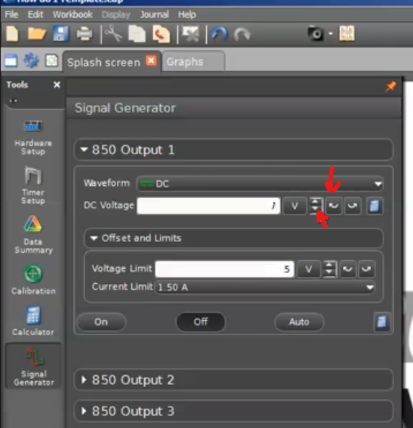
Do at least 19 measurements keeping them equally spaced along the wire (i.e., the linear map). While equal spacing is not a requirement, it helps with the overall accuracy as it reduces the contribution of errors by keeping the differences between the measurements as large as possible (you should not measure the 0cm and should skip 5cm). Record $R_{i}±ΔR_{i}$. Remember that error changes for each measurement as accuracy is different! Does it affect the measurement much? Can the same error be used instead for all points?
Part 2:
Connect the Wheatstone bridge to the power output of the PASCO [1] computer interface. In the Capstone software, configure the readout of the signal generator power output voltmeter and ammeter. Ensure that the voltage limit is at 5V as higher voltage can cause damage to equipment and you as well! Set control to Auto. The up and down buttons should be adjusted by 100mV and not 1V (red arrows).
After settings are verified, make a plot of V vs. time and I vs. time. You can do this as a single run without pressing the stop button. Start the run, adjust the voltage to 0.5V and wait about 20-30 seconds. In steps of 0.5 V go all the way to 5V. After completion of the run, reduce the voltage back to 0V (can be done quickly) and then stop the run.
Use the selection tool and measure the average and standard deviation of V and I for each step. Try to choose the 20-30 rightmost points on each plateau. The displayed standard deviation by the program is statistical error. Move the selection box around, try resizing it, do this 5 times and record the means – the stdev of these is your systematic error. Combine both errors in quadrature as usual to be used as error bars in the plot. Keep data ordered as we want the voltage and the current that correspond to each other. Time information is not needed.

Experimental Data
The results of the measurements should be organized similarly to Table 1. Also, for the voltage and current. Think about how to organize the tables. The error can be listed in a different column or as value ± error unit. Use SI units! Maybe this should be in appendix?
Table 1: Experimental data for which field plate?
Distance, m | Resistance, $Ω$

Provide description about each entry as needed, don’t just leave the table without text in this section. Organize well so that data takes up less space, but everything needed is included.

Theory
Consider equation 1 that shows the expression for resistivity:
$$ρ=R\frac{A}{l} (1)$$
with $R$ being the resistance of the wire segment, and $A and l$ – area and length of the segment. Always use equation editor and number the equations so that they later can be referenced as eq. 1 or equation 1. Other equations may need to be used for this lab. Show any error propagation equations as well! Here you need to use at least one!
Additionally, from Ohm’s law it follows that:
$$R=\frac{V}{I} (2)$$
where R is the resistance, V is the applied voltage, and I is the total current in the circuit.

Analysis
For analysis, we will use Excel or similar spreadsheet software. If you use any professional software, that would be ok, but it must support the necessary features.

Part 1:
We want the slope to be resistivity – what should be the axes? Figure out the total errors for the error bars. Do the plot. If errors bars are not visible, mention this in text. (hint – your Y values may be too small, may be choosing slope to be $ρ/A$ is going to work better for the plot).
Do the trendline, regression, find the resistivity with error.

Part 2:
We want the slope to be resistance – what should be the axes? Figure out the total errors for the error bars. Do the plot. If errors bars are not visible, mention this in text.
Do the trendline, regression, find the total resistance with error.
Use the newfound ability to include both x and y error bars and find the $χ^{2}$ and $χ^{2}/ndf$. The error bars are small as your measurement was very accurate and precise – is your fit quality looking good? Use the chi square to p-value calculator (such as [2] or similar) to convert your $χ^{2}$ and ndf to probability. Is that a good fit? If Ohm’s law is linear, does that fit your result? What if its not? What could be the reason?
Do a plot of residuals. Residuals are the difference between the ‘theoretical’ value given by the fit line equation $f(I_{i})$ and the actual data point value $V_{i}$ (similar to $χ^{2}$ calculation, just not squared!). Does this plot look linear or of any other recognizable shape? Speculate about the reason this may be so.

Conclusion
Remember to include references and appendices as needed. Comment on your result. Try to figure out the material of the wire from the value of resistivity. What did you learn in performing this measurement? Where else can it be used? Can it be improved?

Bibliography

[1] | PASCO Scientific, 10101 Foothills Boulevard, Roseville, California 95747 USA.
[2] | "Chi^2 to P calculator," [Online]. Available: http://courses.atlas.illinois.edu/spring2016/STAT/STAT200/pchisq.html.

